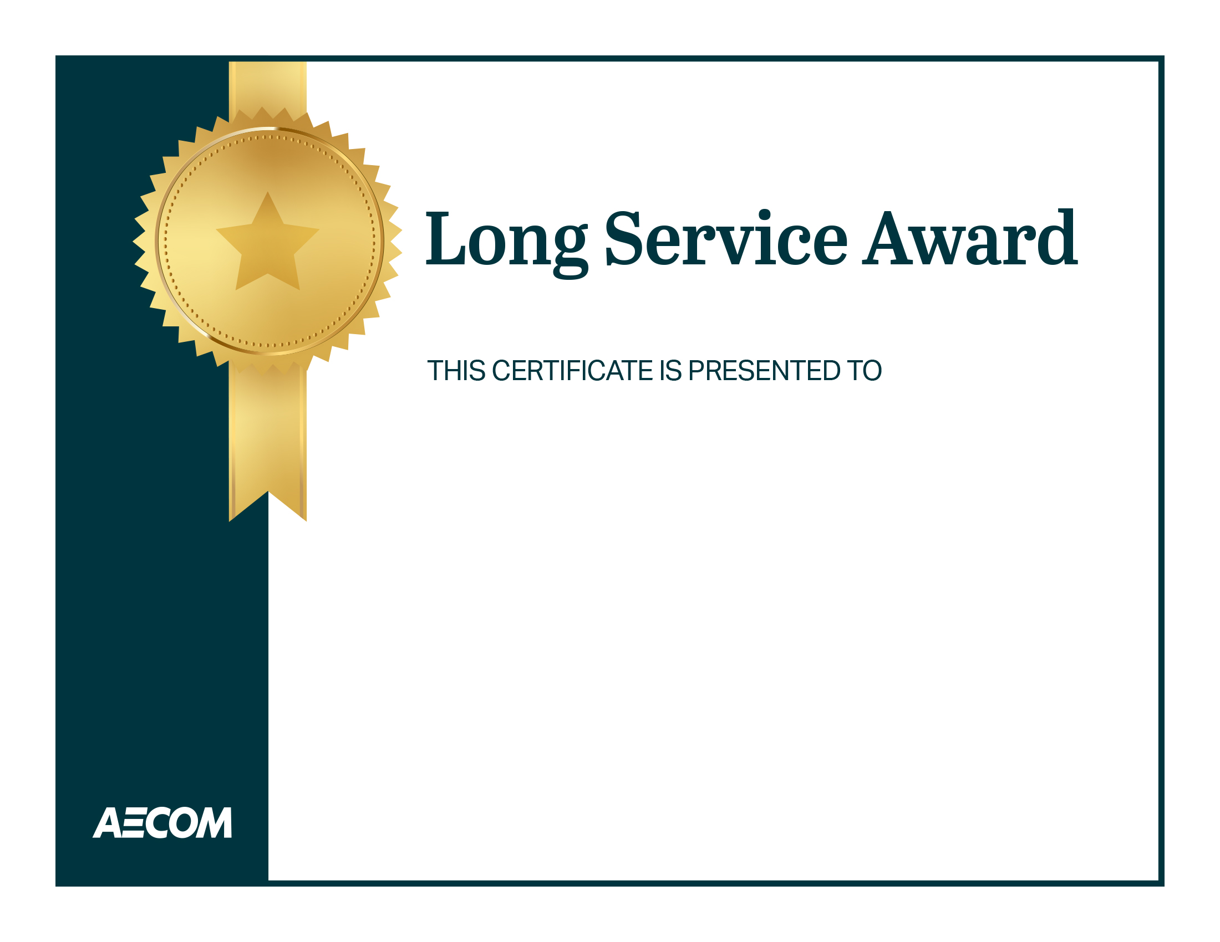

You have reached insert years of service years of service with AECOM!

Thank you for your unwavering commitment and dedication to deliver a better world.

Wishing you many more years of personal and professional success.

**insert your name/signature**

**insert employee's name**